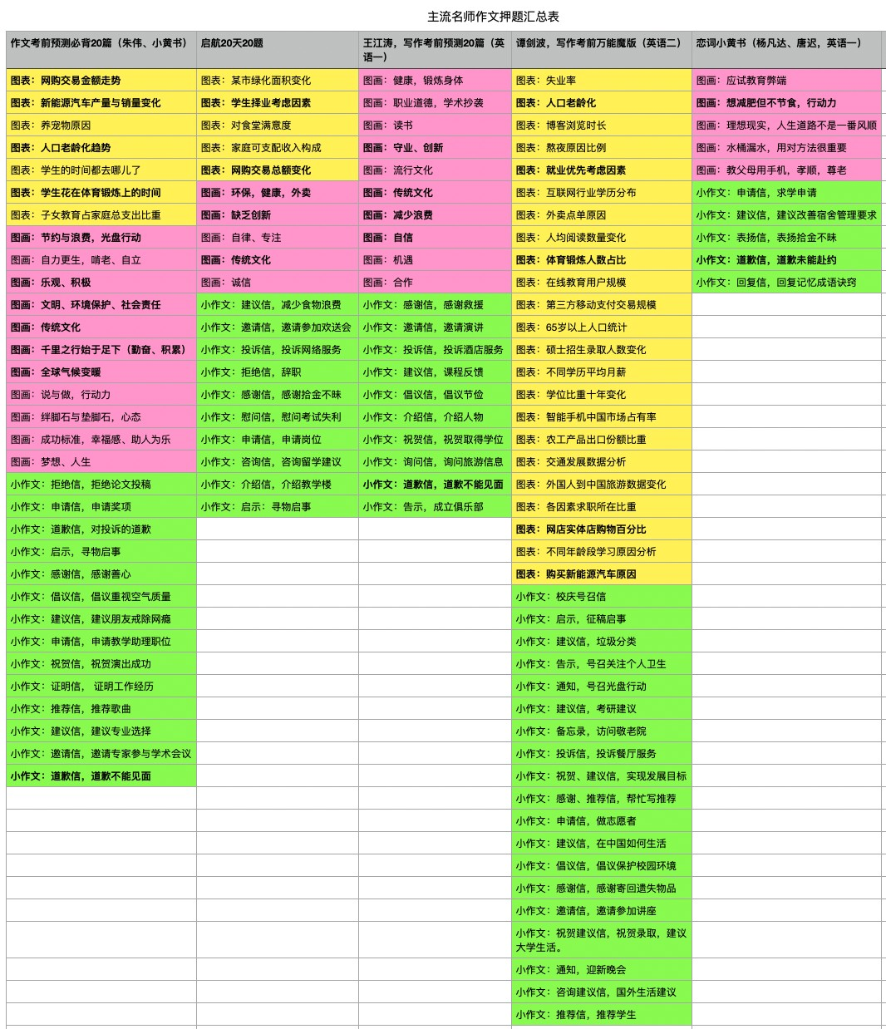
考研英语名师押题统计表

⼀、21考研英语⼤作⽂押题统计（×数字：表示出现次数）：

图画作⽂
- 环保× 3
- 传统⽂化× 3
- 勤奋、⾏动⼒× 3
- 节约和减少浪费× 2
- 乐观、积极、⾃信× 2
- 创新× 2
- 健康，锻炼身体× 2

图表作⽂
- ⽹购× 3
- 新能源汽⻋× 2
- ⼈⼝⽼龄× 2
- 体育锻炼× 2
- 就业择业× 2

考研英语作⽂⾼效率素材汇总

⼆、强适⽤性素材汇总：
标注说明：

红⾊下划线：灵活变动，可以（或需要）替换成其他内容。
⿊体：加分项

⼀、描述图部分：

⼀般英语⼀需要描述图画；英语⼆需要描述图表。
图画的描述分两类：⼀类是存在⼈物；⼀类是不存在⼈物，只有物体。
图表的描述⼀般也分为两类：⼀类是静态图，即描述⽐例；⼀类是动态图，描述⼀定时间的变化。
图表的两类描述都挺简单的，参考任意模版就可写成。图画描述则复杂了不少。
我们对于图画描述的写法进⾏了肢解：
1、如果图画只出现了物体，那么这个物体⼀般都有象征意义。所以你图画描述的句⼦可以是这样的：
An iceberg marked with“success”stands on the sea，dazzling in the sunshine.
⼀座标志着成功的冰⼭矗⽴在海⾯上，在阳光的照耀下，它显得格外耀眼。

这种图⽚的考查可能性很低，所以仅提供⼀句，万⼀考了，可以采⽤类似这样的写法。
2、如果图画出现的是⼈物，则图画描述部分应该写“⼈做了什么”。这⾥的⼈还有动词，给⼤家做了
⼀下整理：

图画作文开头段描述画面常见词
可能出现的⼈物： doctor 医⽣patient 病⼈
college student ⼤学⽣
a young girl／boy ⼀个⼥孩／男孩
a young woman ⼀位年轻⼥⼦

可能出现的动作：

hold 拿、拉（⼿）、举【最⾼频，跟⼿部动作相关】
wear 穿speak 说worry 担 忧 fill 满⾜、装满
fail to notice that 没注意到
teach 教
lie 躺surround 环绕hew 砍
link 链接appreciate 欣赏enjoy 享 受bear 承受
with a joyful look 看上去很⾼⼼
carry 扛、拿
例句：
There is a young boy in the middle of this cartoon, with a delighted face, raising his hand and

facing the front.
图⽚中央有⼀个年轻的男孩，⾯带微笑，举起⼿，⾯向前⽅。

很多同学觉得图画描述没啥好写，或者写不多，写不⻓。其实很简单：⼀般图画描述都有⼈物，⼈物在画⾯的位置，⾯部表情，⼿部动作都可由你表达出来。
⽐如这句话，主⼲只是there be句型。

⼆、第⼆段细节⽀撑
图画作文第二段细节
1、⽬的
From reading extensively, we can derive companionship, experience and instruction.
通过⼤量阅读，我们可以收获友谊，丰富⼈⽣经历，受到教益。
适用于⼀些积极主题，比如英语⼀、⼆往年考的游览博物馆、上⽹等都可以这么说。
延伸：improve our intellectual ability, broaden our minds and make us wise. 提升我们的智⼒、开阔我们的眼界，使我们变得智慧。

2、意义
Apparently, the intended meaning of the drawing is that people are doing less and less exercises now, which is not a piece of good news for their health.
显⽽易⻅，这幅漫画的含义是：⼈们的运动量越来越少，这对于他们的健康⽽⾔并不是什么好消息
适用消极主题，比如历年真题养老主题。对⽗母的忽视对于社会⽽⾔不是好消息。把not删掉，就成积极主题了.
重要性：
Admittedly, garbage classification is quite necessary and can be rewarding.
诚然，垃圾分类是⾮常必要的，并且是有益的。

需要性：
A balanced diet and suﬃcient sleep are both indispensable to physical fitness
均衡的饮⻝和充⾜的睡眠对于身体健康都是不可或缺的。
reading extensively is no less necessary to one's mental life than fresh air to one's physical life.
⼴泛阅读对我们的精神⽣活来说，犹如新鲜空⽓对身体⼀样不可或缺。
亮点：no less 双重否定
3、原因
because exercises never fail to make us stronger and more energetic. 因为运动能让我们更强壮、精⼒更充沛。
亮点：never fail to 双重否定，起到强调作用。
强壮、充沛不只是身体上的，还可以是⼼理上的，适用于常考的比如乐观、耐⼼等等主题。
from a macroscopic view, as integrity exerts enormous impact on the prosperity and harmony of the society, it is no wonder acknowledged as a necessity of this era.
从宏观⻆度看，由于诚信对于社会的繁荣与和谐有巨⼤的影响，所以难怪它被公认为这个时代的必需品。
万能的原因模板
诚信可以替换众多内容——创新、健康、传统⽂化、勤奋…所有的积极内容（积极品质等）
with the rapid development of Chinese economy and the improvement of the living standards of Chinese people, more and more of them can aﬀord trips to foreign countries.
随着中国经济的快速发展和中国⼈⺠⽣活⽔平的提⾼，越来越多的⼈能够负担得起出国旅游 。
英语⼆常用
economic development in the past five years is an essential factor.
这五年内经济的发展起到了关键的作⽤；
英语⼆常用

people's lifestyle is changing.
⼈们的⽣活⽅式正在发⽣改变。
英语⼆常用

the Internet facilitates us in many aspects of life. 互联⽹使我们的⽣活在很多⽅⾯变得⾮常便利。英语⼆常用

The thriving domestic new-energy car market mirrors the socioeconomic development of our country over the past decade.
繁荣发展的国内新能源汽⻋市场反映了我们国家过去⼗年社会经济的发展。
英语⼆常用
with the great goal to build a moderately-prosperous society in all aspects, our government has also implemented a series of policies promoting social development, including taking good care of the elder people.
为了实现全成建设⼩康社会的宏伟⽬标，我国政府也实施了⼀系列促进社会发展的政策，其中包括照顾好⽼年⼈。
英语⼆常用

the unprecedented improvement of the science and technology serves as the material basis for such a situation
科学技术得到了前所未有的提⾼，这为该现象的出现提供了物质基础。
英语⼆常用
Another fact is that social competition is increasingly fierce. Working overtime or even overnight is not uncommon in metropolitan areas, and the number of applicants for postgraduate degrees has broken records for many years in a row.As more and more people struggle to earn a living, they care less about keeping a positive profile in public places.
另⼀个事实是社会竞争越来越激烈。加班甚⾄通宵⼯作在⼤城市不算罕⻅，⽽申请攻读研究⽣学历的⼈数连续多年打破记录。随着越来越多的⼈为⽣计⽽拼搏，他们更不在意在公共场所保持正⾯形象。
算是⼀个适用性很强的描述原因的模板了，来自小黄书，竞争激烈——不在意公共形象，逻辑有些
⽣硬但也能成立，那还有什么不能成立的呢？
Firstly, students who plagiarize on essays or cheat on exams have an unfair advantage over other students.
⾸先，跟其他学⽣相⽐，抄袭论⽂或考试作弊的学⽣拥有不公平的优势。
Secondly, plagiarism and cheating on tests are not only unfair to students who do their own work,
but are also detrimental to a university's reputation and the worth of its diploma.
其次，抄袭和考试作弊不仅对那些⾃⼰好好学习的学⽣不公平，也不利于⼤学的声誉以及⽂凭的含
⾦量。
预测热点，考试作弊原因素材。
the spirit of innovation could be said to be the watchword or motto of science.
创新精神可以说是科学研究的信条。
亮点：watchword or motto ⼝号和格⾔——信条
变动：science变success （成功），适用于⼀切品质，比如你可以说乐观的精神可以说是成l功的信条。

the lack of supervision and penalty on garbage disposal has always been an invisible hand impacting modern people's psychology, characterizing their behavior.
对垃圾处理缺乏监管和处罚⼀直以来都是⼀只⽆形的⼿，影响着现代⼈的⼼理，塑造着他们的⾏为。
万能的原因描写句
4、例⼦
For instance, it would be extremely unjust when a student who cheats on an exam obtains a perfect score of 100, while a bright and hard-working student receives a score of 95.
例如，⼀名考试作弊的学⽣取得了100分的完美分数，⽽⼀名聪明、刻苦的学⽣取得了95分，这⾮常不公平。
预测热点，考试作弊举例素材。
To further illustrate the significance of mutual trust,I would like to take an empirical evidence as a case in point: surveys conducted by an extremely famous career related website have shown that roughly 98% of white-collar workers are more inclined to work with colleagues they trust.
为了进⼀步阐述相互信任的重要性，我在此列举⼀实例予以说明：⼀个知名度颇⾼的职业⽹站经数度调查证实，98%的⽩领⼈⼠更倾向于与⾃⼰信任的同事共事。

举例的写法素材，为了进⼀步阐述主题，我在此列举⼀实例予以说明：⼀个知名度颇⾼的职业⽹站经数度调查证实，自⼰造⼀个数据。

三、第三段细节⽀撑

第三段描述
1、措施：
处罚
vulgar and damaging reality shows should be banned, giving way to those that promote healthy
socialist values.
低俗、具有破坏性的真⼈秀节⽬应当被禁⽌，让位于那些倡导健康的社会主义核⼼价值观的真⼈秀节⽬。

机制
we should appeal to the authorities to make strict laws to control urbanization.
我们应该呼吁政府制定严格的法律来控制城市化。
the real solution still lies in preventing dishonest behaviors and rebuilding trust in society
真正的解决⽅法依然在于预防不诚信⾏为以及重建社会信任。
教育
we should enhance the awareness of people that sustainable development is extremely vital to us.
我们应该提⾼⼈们的意识：可持续发展对我们⾄关重要。
Schools and parents should be aware of this issue and undertake the duty of educating their children into responsible social citizens.
学校和家⻓应该意识到这个问题，并担负起把孩⼦教育成为有责任⼼的社会公⺠的职责。

2、批判
If we keep on ignoring the signal of warning, we will be punished more severely and the survival of our oﬀspring will be threatened.
倘若继续忽视警告信号，我们将受到更加严厉的惩罚⽽⼦孙后代的⽣存亦将受到威胁。
Why don't we cherish them, our spiritual home and our civilization?Without cultural heritage, we would be rootless, unaware of who we are and where we come from, and we would find it hard to cope with challenges at present and in the future.
为什么不珍惜我吗的精神和⽂化家园呢？没有这些⽂化遗产，我们就没有了根，就不知道我们是谁，来⾃何⽅，也就很难应对眼下和未来的挑战。
3、观点
we should put great emphasis on forming good habits.
我们应该重视养成良好习惯。
More importantly, an optimistic attitude toward life makes me confident and persistent.
更为重要的是，乐观的⽣活态度使我充满⾃信，坚持不懈。
nothing can replace the role that reading plays in our lives.
没有什么能取代阅读在我们⽣活中的作⽤。

可以将阅读改称⼀切品质（毅⼒、乐观等）。
To sum up, in any field of endeavour, whether it be in medicine, engineering or in business, it seems necessary to put great emphasis on innovation before one can finally achieve success. 总之，在任何领域，⽆论是医学、⼯程还是商业，⼀个⼈似乎只有重视创新，才能获得最后的成功。
the future of China's traditional culture will be brighter and more secure than ever before.中国传统
⽂化的未来将会⽐过去任何时候更光明，更安全。

